Prompt 1: Driver Registration Test Cases
Task: Generate test cases for the Driver Registration module of the CORADS system based on the SRS document.
Prompt:
- "Generate test cases for the Driver Registration module of the CORADS system based on the provided SRS document.
  - The AI should behave like a Principle Quality Engineer with over 20 years of experience in the field, ensuring high-quality, human-readable test cases.
  - Test cases should be written in a clear, easy-to-understand manner, resembling the style of an experienced quality engineer. Avoid jargon and ensure the test cases are accessible to all team members, from developers to non-technical stakeholders.
  - Use the following test case structure:
- Test Case ID: Unique identifier (e.g., DRT-01).
- Test Description: A brief, clear description of the test (e.g., "Verify the form displays correctly").
- Preconditions: Conditions that must be met before executing the test (e.g., "Driver is logged into the system").
- Test Steps: Step-by-step instructions on how to perform the test (e.g., "Click the 'Add New Driver' button").
- Test Data: Input data used for the test (e.g., "Valid driver information: Name, Phone, Email").
- Expected Result: What the system is expected to do (e.g., "Driver registration form should appear").
- Postconditions: What should happen after the test is executed (e.g., "Driver is registered in the system").
- Pass/Fail Criteria: How to determine if the test passes or fails (e.g., "System correctly validates input data and displays the success message").
- Priority: Rank the test case as High, Medium, or Low priority.
- Test Environment: The environment where the test is performed (e.g., "Android 9.0, Google Chrome").
  - Ensure edge cases are thoroughly tested (e.g., invalid inputs, boundary values).
  - Test for mobile responsiveness, device compatibility, and interoperability across different platforms (Google Chrome, Opera Mini, Safari, etc.).
  - Avoid hallucination—only generate test case data grounded in the provided SRS and human-written test cases.
  - Follow IEEE 829 or similar standards for the test case format.

Summary:
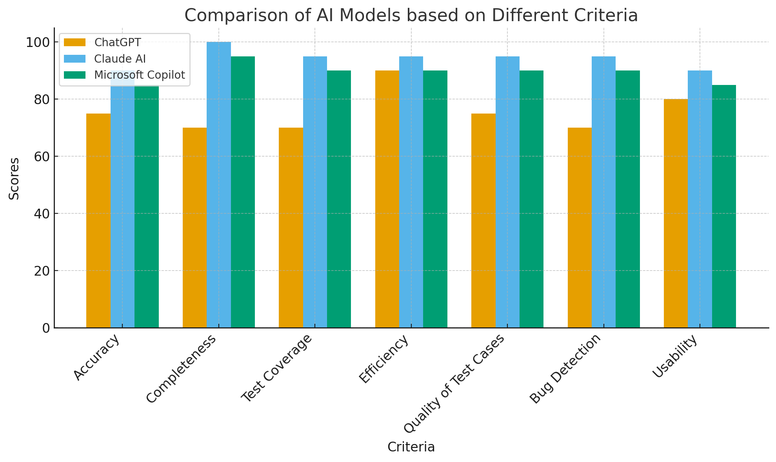
Assigned Scores for AI-Generated Test Cases (1-100)
Criterion | ChatGPT | Claude AI | Microsoft Copilot
1. Accuracy | 75 | 90 | 85
2. Completeness | 70 | 100 | 95
3. Test Coverage | 70 | 95 | 90
4. Efficiency | 90 | 95 | 90
5. Quality of Test Cases | 75 | 95 | 90
6. Bug Detection | 70 | 95 | 90
7. Usability | 80 | 90 | 85
Sum of Scores | 530 | 660 | 625

1. Claude AI (Rank 1 - Score: 94.29)
Claude AI is the top performer, aligning with your preference, due to its Completeness (100) and high scores in Quality and Bug Detection. The output was not just a list of tests but a comprehensive Test Suite Design document, including:
- Structured Metadata: Total test case count (20), a formal Priority Breakdown, and a detailed list of Coverage Areas (e.g., Data integrity, Network handling, Security).
- Advanced Bug Detection: It specifically covered complex, deep-level edge cases such as "Application Crash data retention" and detailed boundary conditions.
2. Microsoft Copilot (Rank 2 - Score: 89.29)
Copilot provided a very strong, professional set of test cases, particularly excelling in Test Coverage and Bug Detection (90).
- It showed a clear focus on Non-Functional Requirements (NFRs) like Boundary Value Analysis (max lengths, Unicode characters) and Performance (screen load time within 3 seconds).
- It offered high Quality and Usability, structuring tests for immediate practical execution.
3. ChatGPT (Rank 3 - Score: 75.71)
Your observation that the ChatGPT report was the worst is reflected in the scores, particularly the lower scores for Completeness (70), Test Coverage (70), and Bug Detection (70).
- Low Volume: As you noted, it generated only 6 test cases, focusing primarily on the most basic functional happy paths and single-field validation failures.
- Lack of Depth: It completely missed complex requirements such as boundary checks, non-functional testing (performance, security, concurrency), and advanced error handling (network interruptions, data persistence).
- Strengths: Its only relative strength was high Efficiency, as it rapidly produced a small, clean, and immediately readable, albeit simplistic, test list.

